1. What is Normalization & Standardization and how is it helpful?

Definitions
- Normalization: Rescaling data to a specific range (commonly 0 to 1).
Formula:
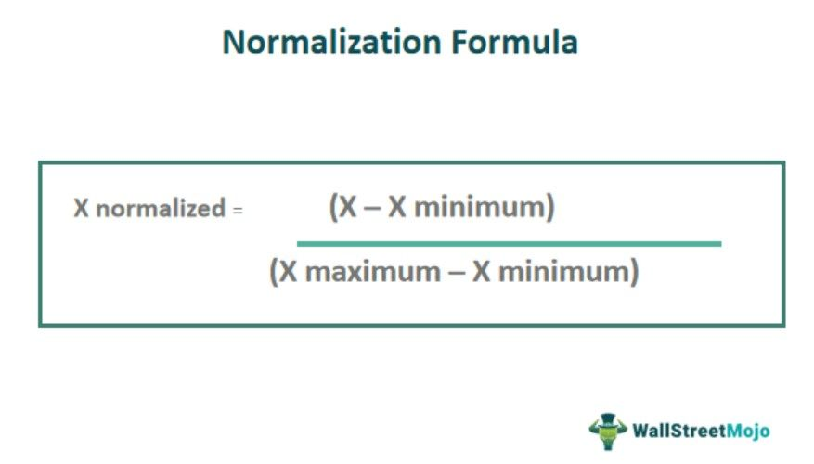
- Standardization: Rescaling data to have a mean of 0 and standard deviation of 1.
Formula:
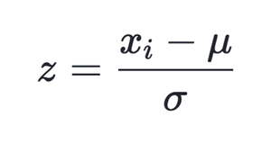

Why it is helpful
- Ensures all features are on the same scale → prevents bias toward features with larger magnitudes.
- Improves convergence of gradient-based algorithms (e.g., Linear Regression with gradient descent, Neural Networks).
- Important for distance-based models like KNN, K-Means, where scale affects distance calculation.
- Standardization is often preferred when the data has outliers because it does not bound values strictly between 0 and 1 like normalization does.

Example :
import pandas as pd
from sklearn.preprocessing import MinMaxScaler, StandardScaler

# Sample dataset
df = pd.DataFrame({
"Age": [20, 25, 30, 35, 40],
"Salary": [20000, 25000, 40000, 60000, 80000]
})

# Normalization (0 to 1 range)
scaler_norm = MinMaxScaler()
df_norm = pd.DataFrame(scaler_norm.fit_transform(df), columns=df.columns)
print("Normalized Data:\n", df_norm)

# Standardization (mean=0, std=1)
scaler_std = StandardScaler()
df_std = pd.DataFrame(scaler_std.fit_transform(df), columns=df.columns)
print("Standardized Data:\n", df_std)

2. Techniques to address multicollinearity in Multiple Linear Regression

Definition of Multicollinearity
- Occurs when independent variables (features) are highly correlated.
- Can inflate variance of coefficient estimates → unreliable predictions.

Detection Methods
  - Correlation Matrix: High correlation (>0.8 or 0.9) between features

Ex:
corr_matrix = df.corr()
print(corr_matrix)

  - Variance Inflation Factor (VIF): Measures how much the variance of a coefficient is inflated due to multicollinearity.
Formula:

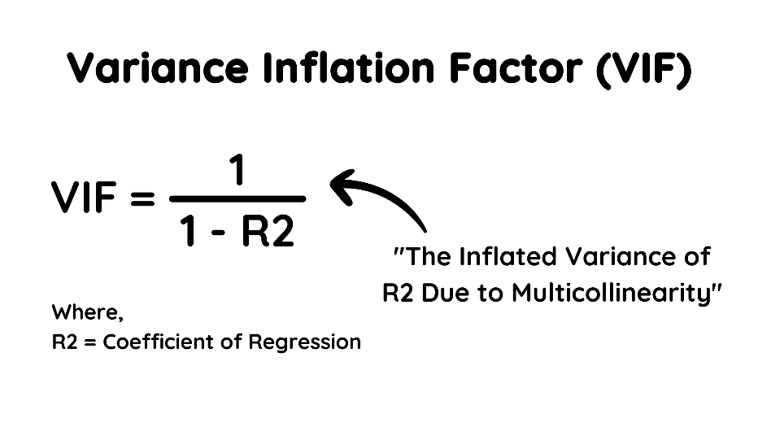

Example :

from statsmodels.stats.outliers_influence import variance_inflation_factor

# Assuming df contains only numeric features
X = df[["Age", "Salary"]]
vif = pd.DataFrame()
vif["Feature"] = X.columns
vif["VIF"] = [variance_inflation_factor(X.values, i) for i in range(X.shape[1])]
print(vif)

Techniques to handle multicollinearity
- Remove highly correlated features
  - Drop one of the variables from pairs with correlation >0.8.
- Combine variables
  - E.g., take the mean or PCA (Principal Component Analysis).
- Use regularization
  - Ridge Regression (L2): Shrinks coefficients, reduces variance.
  - Lasso Regression (L1): Can shrink some coefficients to zero → feature selection.
- Increase sample size
  - Helps reduce variance and stabilizes coefficient estimates.
Assumptions & Implications:
- Assumes linear relationships between predictors.
- Ignoring multicollinearity can lead to unstable coefficients, misinterpretation, and poor generalization.
- Regularization methods may slightly bias coefficients but improve predictive performance.

